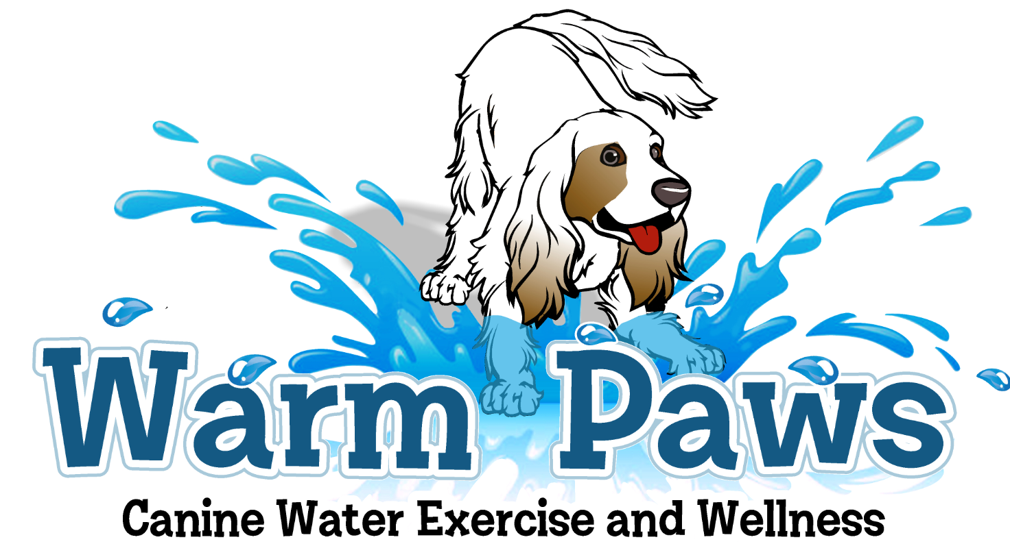
VETERINARY APPROVAL
Warm Paws requires written veterinary approval for all dogs under veterinary care for a current medical condition, post-injury or post-surgical care before swimming your dog.
Pet’s Name: ______________________________________________
Owner’s Name: __________________________________________
Owner Phone: ____________________ Email:_____________________________________
VETERINARIAN
Are indoor swimming (in 90ºwarm water pool)
And/or warm water soaking appropriate for this dog? ☐ YES ☐ NO

Please list any activity restrictions:

Please list any special instructions or precautions:

Goals:

I would like the owner to see me by: _____________________________________

Veterinarian Signature: _______________________________ Date: ________________
Veterinarian Name (print): ____________________________ Phone: _______________

Warm Paws – Cherie Dobish 724.513.0803

Warm Paws does not diagnose or treat injuries, disease or illness. All holistic modalities are not substitutes for proper veterinary care. Warm Paws is certified and insured.

